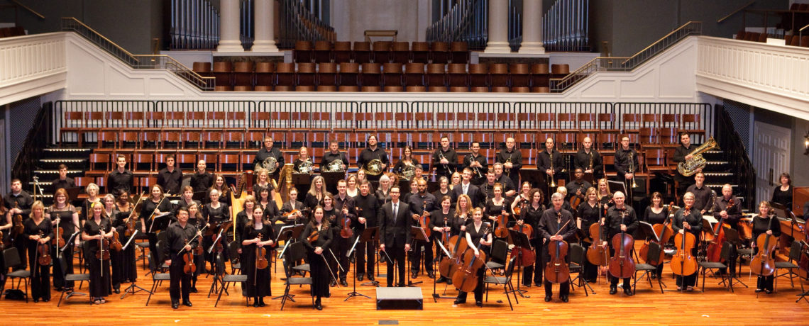
We have an opportunity to observe the Cello section of the Nashville Philharmonic Orchestra as they read through chamber music arranged for 4 and 6 celli for the pure enjoyment of getting together and playing.

- When: Tuesday, August 16
- Where: Abbottsford Clubhouse
- Time: 7:00 until 9:00

Abbottsford neighbors, this is a unique experience to “peek behind the scenes” and share in the fun that a group of cellists, all part of the Nashville Philharmonic Orchestra’s Cello section, can have when they get together for what might be called a classical music jam session.

They initially wanted to get together at one of their homes and then realized, why not share, and have anyone who is interested listen to their session and see what it is like for a group of musicians to enjoy playing. You are welcome to come for the entire session or for the time that fits your schedule.

The group will be reading some of the following music. (The order may change.)
- Tchaikovsky Nutcracker Suite – selections - arranged for 6-Part Cello Orchestra
- R. Wagner – Tannhauser Overture – arranged for 4 celli
- Mozart – Eine Kleine Nachtmusik – first movement – arranged for 4 celli
- Purcell – selections from Henry Purcell Suite from Abdelazer Z.570 – arranged for 4 celli
- G. Golterman – Serenade for Four Cellos, Op. 119, No. 2
- Mozart – Sinfonia zu “Le nozze de Figaro” – arranged for 4 celli (Marriage of Figaro overture)

They will take a short break. Feel free to ask questions during the evening, as this is intended to be an informal get-together. Children are especially welcome. The Entertainment Committee will provide refreshments.

For questions about the music and the degree of informality they will encourage, please contact our neighbor Paul Garnett pgarnett@msisinc.com.

