Updated times for
Halloween in Abbottsford

When | 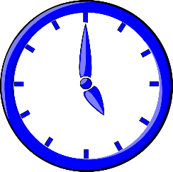 | Monday, October 31  5:00pm until 7:30pm  On this school day some children cannot start their Trick-Treat journey early, so we are giving them extra time.

 | Weather Prediction | We do not have a “crystal ball” so we consulted another crystal ball, known as the 10-day weather forecast. The temperature during our Trick-Treat time is supposed to be in the low 60’s and clear!

 |  | We hope that as many Abbottsford residents as possible will participate with giving treats on Halloween. We are asking residents to be on the lookout for the young people and either greet them or have a tray of goodies available for our cute or spooky guests to collect.  If you are not passing out treats, please do keep your lights as low as possible so not as to attract children.

